**NIST SP 800-171**

NIST SP 800-171 was created as a framework for government contractors to develop procedures to aid in assessing the satisfaction of compliance of CUI security. The procedures and methods are generalized so organizations can be flexible in their implementation of achieving their goals of compliance. It allows for self-assessment and voluntary compliance.

NIST SP 800-171 helps organizations gather information and make assessments of their systems so the organization can next:

• “*Identify potential problems or shortfalls in the organization’s security and risk management*

*programs;*

*• Identify security weaknesses and deficiencies in its systems and in the environments in which*

*those systems operate;*

*• Prioritize risk mitigation decisions and activities;*

*• Confirm that identified security weaknesses and deficiencies in the system and in the*

*environment of operation have been addressed; and*

*• Support continuous monitoring activities and provide information security situational*

*awareness” (p.1).*

<https://nvlpubs.nist.gov/nistpubs/SpecialPublications/NIST.SP.800-171A.pdf>

**Compared to CMMC**

Where NIST SP 800-171 consists of guidance and recommendations for voluntary compliance of CUI, CMMC was created as a mandatory compliance certification and is quickly becoming the industry standard in order to compete with other organizations for government contracts. “Assessments are conducted by CMMC Third-Party Assessment Organizations (C3PAOs) and Certified Assessors” (p. 13).

Levels 1 through 3 of CMMC are taken partially from SP 800-171.

<https://www.acq.osd.mil/cmmc/docs/CMMC_AG_Lvl3_20201208_editable.pdf>

A CMMC Level 1 audit will cover 15% of the NIST 800-171 CUI controls.

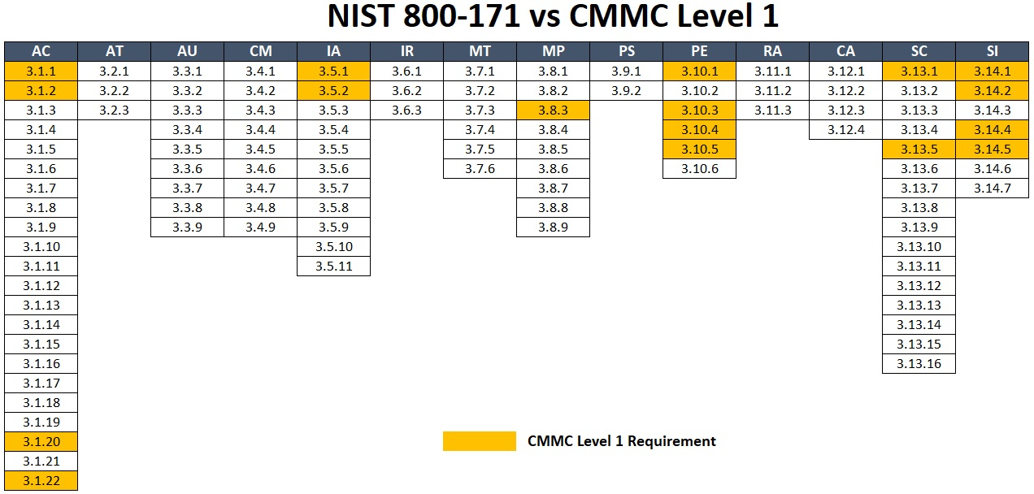

<https://www.complianceforge.com/blog/nist-800171-vs-cmmc/>

There are 72 controls that make up CMMC Level 2, which encompasses the CMMC Level 1 controls. A CMMC Level 2 audit will cover 65% of the NIST 800-171 CUI controls.

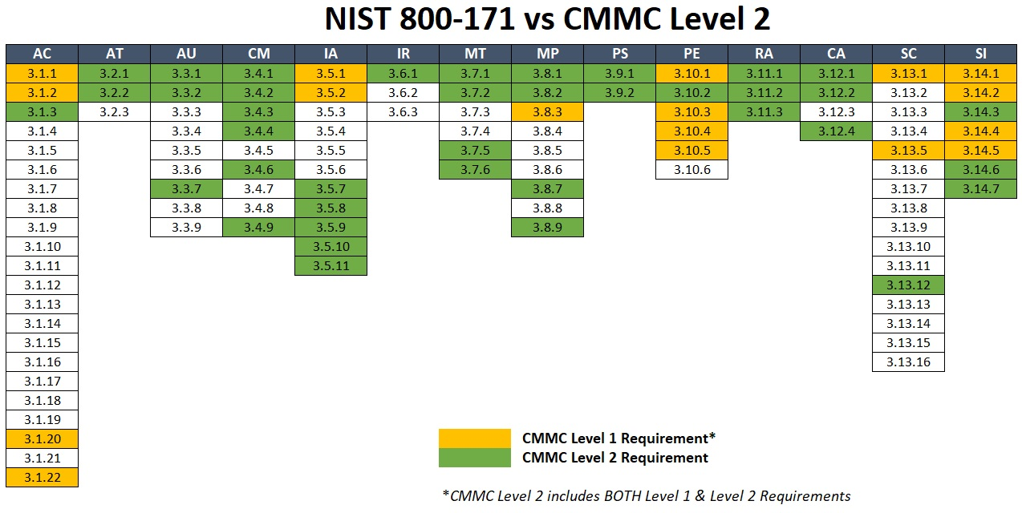

<https://www.complianceforge.com/blog/nist-800171-vs-cmmc/>

There are 131 controls that make up CMMC Level 3, which encompasses the CMMC Level 1 & 2 controls. A CMMC Level 3 audit will cover 100% of the NIST 800-171 CUI controls and an additional 21 controls from various sources.

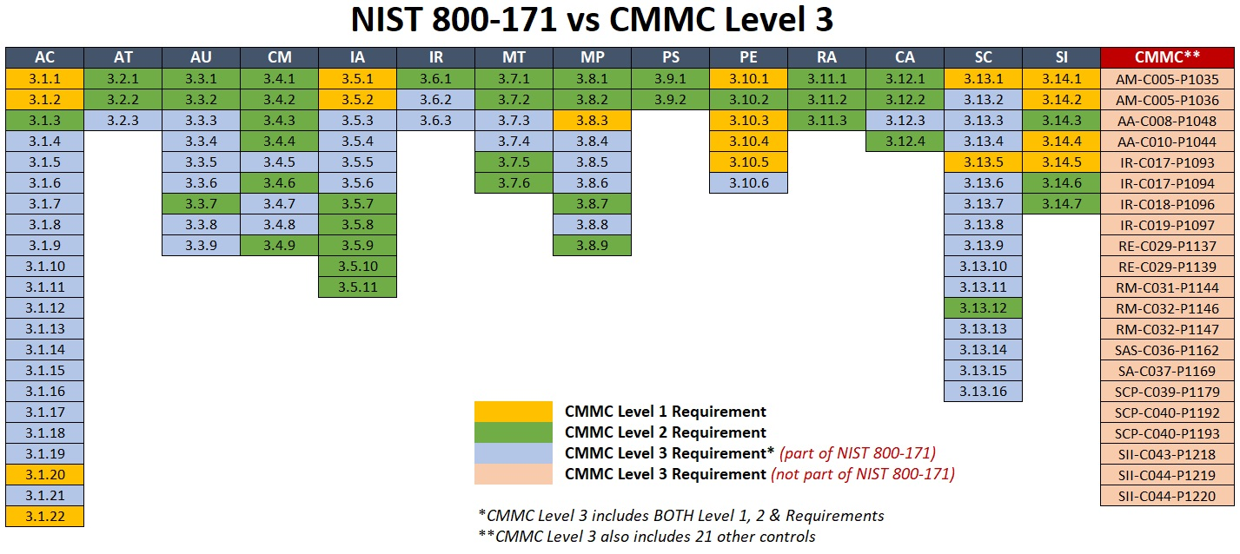

<https://www.complianceforge.com/blog/nist-800171-vs-cmmc/>

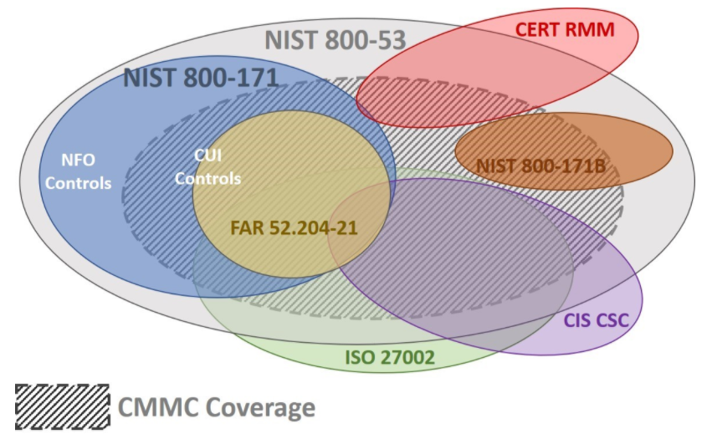

<https://www.complianceforge.com/blog/nist-800171-vs-cmmc/>